Step1:First we login into the jenkins home page and create the new job with Freestyle project.

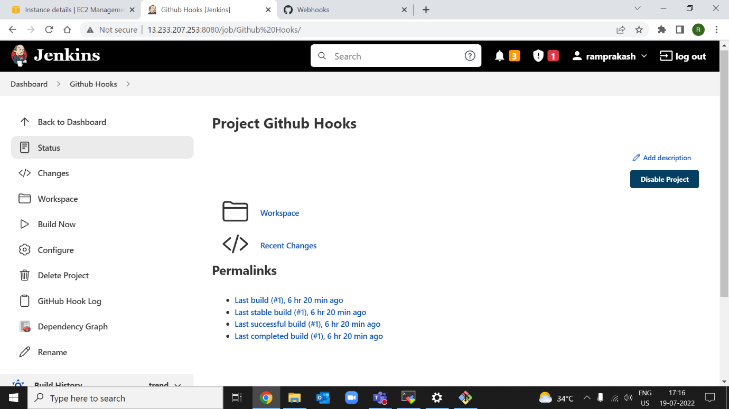\

Step2:Afterthat goto the github page and goto the repository settings and choose the webhook option and add the webhook with the jenkins URL

Step3: And Now we configure the Job with the Github URL and Build it

